**THE SUPERIOR COLLEGE LAHORE**

|  |
| --- |
|  |

**Faculty of Computer Science & IT**

**Department of Software Engineering**

**Final Year Project**

**PROJECT REPORT (Part-1)**

**[Citizen Health Portal]**

Project ID:**[write ID here Issued by FYP Manager]**

**Project Team**

|  |  |  |  |  |
| --- | --- | --- | --- | --- |
| **Student Name** | **Student ID** | **Program** | **Contact Number** | **Email Address** |
| Asad Ali Rana | Bcsm-s17-036 | BSCS | 03065366036 | [Asadalirana62@gmail.com](mailto:Asadalirana62@gmail.com) |
| Muhammad Hamza | Bcsm-s17-028 | BSCS | 03134645610 | Bcsm-s17-028@superior.edu.pk |
| M Farooq Usman | Bcsm-s17-031 | BSCS | 03180730876 | Bcsm-s17-031@superior.edu.pk |
|  |  |  |  |  |
|  |  |  |  |  |

**[Project Supervisor]**

([Designation])

**Project Report**

**[Citizen Health Portal]**

**Change Record**

|  |  |  |  |  |
| --- | --- | --- | --- | --- |
| **Author(s)** | **Version** | **Date** | **Notes** | **Supervisor’s Signature** |
| Asad Ali, M Hamza, Farooq Usman | 1.0 | 19-04-2020 | <Original Draft> |  |
|  |  |  | <Changes Based on Feedback from Supervisor> |  |
|  |  |  | <Changes Based on Feedback From Faculty> |  |
|  |  |  | <Added Project Plan> |  |
|  |  |  | <Changes Based on Feedback from Supervisor> |  |
|  |  |  |  |  |
|  |  |  |  |  |
|  |  |  |  |  |
|  |  |  |  |  |
|  |  |  |  |  |

**APPROVAL**

|  |  |
| --- | --- |
| **Project Supervisor** | |
| Comments: ___________________________________________________________________ | | |
| _____________________________________________________________________________ | | |
| Name:______________________________ |  | |
| Date:_______________________________ | Signature:__________________________ | |

|  |  |
| --- | --- |
| **Project Manager** | |
| Comments: ___________________________________________________________________ | |
| _____________________________________________________________________________ | |
|  |  |
| Date:_______________________________ | Signature:__________________________ |

|  |  |
| --- | --- |
| **Head of the Department** | |
| Comments: ___________________________________________________________________ | |
| _____________________________________________________________________________ | |
|  |  |
| Date:_______________________________ | Signature:__________________________ |

# Dedication

We dedicate this work to our Almighty ALLAH, our Creator who enable or help us to doing work on this project, our great Teachers who taught us and guide us, our Parents who never stop giving themselves in countless ways, our Supervisor who help us to complete our project, to Administrators of Computer Science Department for their help and support throughout the degree.

# Acknowledgements

We are thankful to **Almighty ALLAH**, the Master, the most Merciful who gave us His blessing and His **Prophet HAZRAT MUHAMMAD (P.B.U.H)** who taught us to get knowledge is compulsory for all Muslim.

Firstly, We would like to express our deepest thanks to respective project supervisor, Department of Computer Science, The Superior University Lahore, for her guidance, supervision, valuable suggestions, technical help and help to complete this as well as for writing this document.

We would like to thanks our Parents who helped us in each and every situation and Family who prayed for our success.

**(Asad Ali, M Hamza, M Farooq Usman)**

# Executive Summary

In our health department there is not a single hospital that gives easy online access to their patient’s guardian for treatment data. With the rapid development of smart phones and mobile devices, it becomes very popular that people more prefer to access the information through this flexible way. Citizen Health Portal will be an online plate form where all medical facilities will provide through online system. There is an increased emphasis on patients taking a more active role in managing their health information, which has been associated with better clinical outcomes and patient empowerment.

CITIZEN Health PORTAL will help healthcare facilities and provides a technology that supports patient and doctor, access to the patient’s health information. Our aim is to move the Pakistan towards a more patient focused health care system where there is collaboration between the Patient and the Doctor. This way we can improve the quality and safety of healthcare, decrease costs, and patient satisfaction increases.

# Table of Contents

Dedication iv

Acknowledgements v

Executive Summary vi

Table of Contents vii

List of Figures ix

List of Tables x

Chapter 1 1

Introduction 1

1.1. Background 2

1.2. Motivations and Challenges 2

1.3. Goals and Objectives 2

1.4. Literature Review/Existing Solutions 2

1.5. Gap Analysis 2

1.6. Proposed Solution 2

1.7. Project Plan 3

1.7.1. Work Breakdown Structure 3

1.7.2. Roles & Responsibility Matrix 3

1.7.3. Gantt Chart 3

1.8. Report Outline 3

Chapter 2 4

Software Requirement Specifications 4

2.1. Introduction 5

2.1.1. Purpose 5

2.1.2. Document Conventions 5

2.1.3. Intended Audience and Reading Suggestions 5

2.1.4. Product Scope 5

2.1.5. References 6

2.2. Overall Description 6

2.2.1. Product Perspective 6

2.2.2. Product Functions 6

2.2.3. User Classes and Characteristics 6

2.2.4. Operating Environment 7

2.2.5. Design and Implementation Constraints 7

2.2.6. User Documentation 7

2.2.7. Assumptions and Dependencies 7

2.3. External Interface Requirements 8

2.3.1. User Interfaces 8

2.3.2. Hardware Interfaces 8

2.3.3. Software Interfaces 8

2.3.4. Communications Interfaces 9

2.4. System Features 9

2.4.1. System Feature 1 9

2.4.1.1. Description and Priority 9

2.4.1.2. Stimulus/Response Sequences 9

2.4.1.3. Functional Requirements 9

2.4.2. System Feature 2 10

2.4.2.1. Description and Priority 10

2.4.2.2. Stimulus/Response Sequences 10

2.4.2.3. Functional Requirements 10

2.4.3. System Feature 3 (and so on) 11

2.5. Other Nonfunctional Requirements 11

2.5.1. Performance Requirements 11

2.5.2. Safety Requirements 11

2.5.3. Security Requirements 12

2.5.4. Software Quality Attributes 12

2.5.5. Business Rules 12

2.6. Other Requirements 12

Chapter 3 13

Use Case Analysis 13

3.1. Use Case Model 14

3.2. Fully Dressed Use Cases 14

Chapter 4 15

System Design 15

4.1. Architecture Diagram 16

4.2. Domain Model 16

4.3. Entity Relationship Diagram with data dictionary 16

4.4. Class Diagram 17

4.5. Sequence / Collaboration Diagram 17

4.6. Operation contracts 17

4.7. Activity Diagram 18

4.8. State Transition Diagram 18

4.9. Component Diagram 18

4.10. Deployment Diagram 19

4.11. Data Flow diagram [only if structured approach is used - Level 0 and 1] 19

Chapter 5 20

Implementation 20

5.1. Important Flow Control/Pseudo codes 21

5.2. Components, Libraries, Web Services and stubs 21

5.3. Deployment Environment 21

5.4. Tools and Techniques 22

5.5. Best Practices / Coding Standards 22

5.6. Version Control 22

Appendices 23

Appendix A: Information / Promotional Material 24

Reference and Bibliography 27

Index 29

# 

# List of Figures

1.1 Caption of first figure of first chapter 6

1.2 Caption of second figure of first chapter 7

2.1 Caption of first figure of second chapter 14

2.2 Caption of second figure of second chapter 22

2.3 Caption of third figure of second chapter 26

5.1 Caption of first figure of fifth chapter 49

5.2 Caption of second figure of fifth chapter 49

# List of Tables

1.1 label of first table of first chapter 6

1.2 label of second table of first chapter 7

2.1 label of first table of second chapter 14

2.2 label of second table of second chapter 22

2.3 label of third table of second chapter 26

5.1 label of first table of fifth chapter 49

5.2 label of second table of fifth chapter 49

# Chapter 1

# Introduction

**Chapter 1:** Introduction

Currently in most medical, Health care and diagnose centers manual system is used for maintenance of information of their patients. Some of them have their own systems to maintain their patient’s data. If someone is visiting a doctor for consultation then he/she needs to be physically present at that doctor’s place for appointment. Newly diagnosed patients with numerous diseases had to take the overhead for searching of suitable doctors, hospitals, pharmacies, laboratories and blood banks.

We are aiming to develop a health care system which will provide the medical history of a patient to a doctor upon NIC number as it is unique for every person*.*

## Background

In our health department there is not a single hospital who gives easy online access to their patient’s guardian for treatment data. With the rapid development of smart phones and mobile devices, it becomes very popular that people more prefer to access the information through this flexible way. Citizen Health Portal will be an online plate form where all medical facilities will provide through online system. There is an increased emphasis on patients taking a more active role in managing their health information, which has been associated with better clinical outcomes and patient empowerment.

CITIZEN Health PORTAL will help healthcare facilities and provides a technology that supports patient access to their health information. Our aim is to move the Pakistan towards a more patient focused health care system where there is collaboration between the Patient and the Doctor.

## Motivations and Challenges

Citizen Health Portal mainly targets on providing online platform to health care providers and patients. It covers different aspects of making appointment of doctors. Patients can retrieve and share their medical history with the doctor. It facilitate patients in finding best rated doctors, pharmacies, laboratories, hospitals and blood banks and will give alerts to patients for their dozes and appointments. It also recommends doctor to patients based upon their medical history. The motivation to build the system is to reduce the problem that occurs when using the manual system and helps patients to skip endless queues that waste a lot of time, energy and paper.

## Goals and Objectives

Objective of Citizen Health Portal is to improve the accessibility of healthcare providers. Citizen Health Portal will provide a web-based application for doctors and patients.

• Patient self-medication

• Reduced effort to keep personal patient data up to date

• Stronger relationship between doctor and patient

• Increased effectiveness of patient care, thereby cost saving

• Increased quality of care

• To research and health reporting

## Literature Review/Existing Solutions

* **MyUSAHealth**

MyUSAHealth is the portal for existing patients who may have questions about ongoing patient care, treatments or prescription renewals. You also can view or cancel upcoming appointments, message your provider directly, see visit history, access your medical records, and even view lab and surgery reports.

* **NHP India**

The Ministry of Health and Family Welfare, Government of India has set up the National Health Portal in pursuance to the decisions of the National Knowledge Commission, to provide healthcare related information to the citizens of India and to serve as a single point of access for consolidated health information. The National Institute of Health and Family Welfare (NIHFW) has established Centre for Health Informatics to be the secretariat for managing the activities of the National Health Portal.

* **mednise.com**

Mednise.com gives users looking for better healthcare, exclusive access to top medical minds in the world to insure that they have the right diagnosis and right treatment plans

## Gap Analysis

The GAP analysis tells use what skills we have and what skills do we need to improve our performance to achieve our goals on time with client’s satisfaction and to make good PR in the industry.

|  |  |  |
| --- | --- | --- |
| Have | Need to Have | Actions |
| Ability to work in team. | Ability to work more effectively in teams by understanding weaknesses and strengths of other team members. | Self-assessment in groups, more team work exercises. |
| Ability to learn new skills. | Need to skills to develop a more efficient and sustainable commercial product for market. | Practice more and more precisely to have ability to grasp the concepts and surveys to enhance the ideas to work on. |
| Communication Skills | Clarity of thoughts for communication and articulating visions to have better understanding within the team and with the clients. | Learn how to communicate professionally to sum up the things precisely so the other person don’t get deviated. |

## Proposed Solution

This project is all about the technology awareness of the local civilians of Pakistan for Health Care. As currently there is no single such system working in Pakistan for Health Care. This Portal will control healthcare and benefit costs while engaging Patients with interactive tools to improve their personal health and wellness

## Project Plan

These Steps are involved in project plan:-

**1-Information Gathering**

Information Gathering is the act of gathering different kinds of information against the targeted victim or system. In this step we gather the information with the help of brain storming, Interviewing and feedback.

**2-Requirement Analysis**

**Requirements analysis** focuses on the tasks that determine the needs or conditions to meet the new or altered product or project, taking account of the possibly conflicting requirements of the various stakeholders, *analyzing, documenting, validating and managing* software or system requirements. In this step we analyze the information.

**3-Design**

In the design phase deals with transforming the customer requirements as describe in the SRS documents into a form implementable using a programming language.

The design process can be divided into the following three levels of phases of design:

1. Interface Design
2. Architectural Design
3. Detailed Design

**4-Implementation**

In this phase we start to implement our project. The project takes shape during the implementation phase. This phase involves the construction of the actual project result. It is during this phase that the project becomes visible to outsiders, to whom it may appear that the project has just begun.

**5-Testing**

In The testing phase we focus on investigation and discovery. During the **testing phase**, we can find out whether the code and programming work according to customer requirements. And while it's not possible to solve all the failures you might find during the testing phase, it is possible to use the results from this phase to reduce the number of errors within the software program.

**6-Deployment**

The deployment phase is the final phase of the project planand puts the product into production. After the project team tests the product and the product passes each testing phase, the product is ready to go live

## Work Breakdown Structure

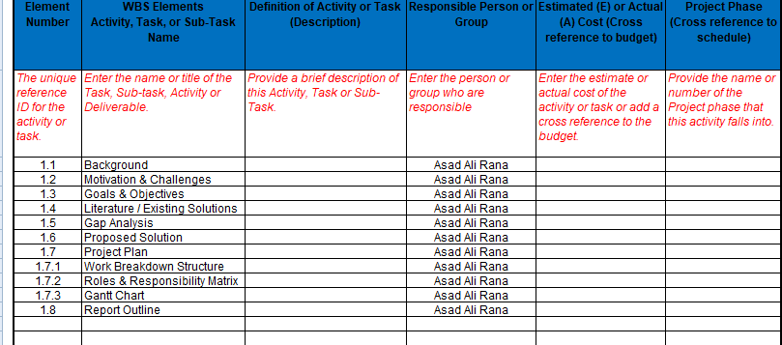

## Roles & Responsibility Matrix

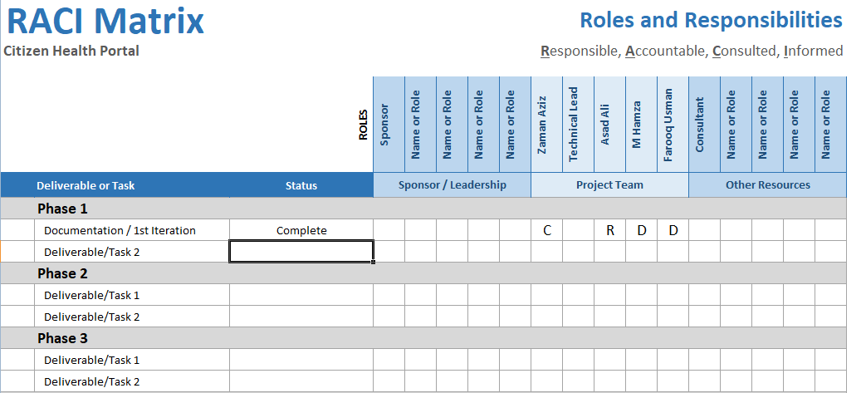

## Gantt Chart

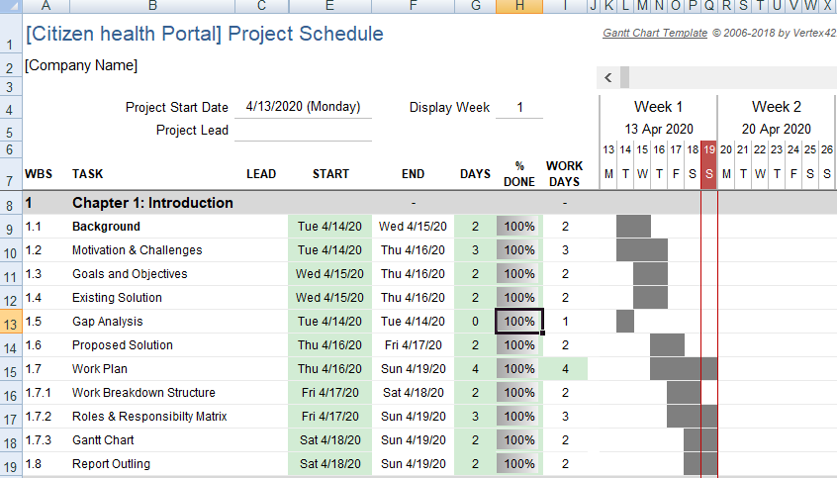

## Report Outline

* Patient / Doctor registration
* Patient / Doctor login
* Patient can search for the best doctors in town for his/her medical treatment
* Doctor can check patient’s complete medical history online using patient’s unique ID/b-form number.
* In case of accidental death the body can be identified using thumb impression instead of DNA test process.
* Doctor can suggest medication to patient.
* Patient will get notification for medicine dose.
* Patient can communicate with doctor online for minor problems and can pay through jazz-cash, easy-paisa money transfers.

# Chapter 2

# Software Requirement Specifications

**Chapter 2:** Software Requirement Specifications



## Introduction

## Purpose

The purpose of SRS document is to provide a detailed overview of our software product also its parameters and goals. This document provides internal working of software how its work or interact with users of the system. This document describes the projects target audience and its user interface, hardware and software requirements. SRS document helps any designer and developer to assist in software delivery lifecycle (SDLC) processes.

Moreover, this document also has software system constraints, interface and interactions with other external applications and data maintain in database or flow of data.

## Document Conventions

The font style used in this documentation is **ARIAL** and the font size is **12.**

## 

## Intended Audience and Reading Suggestions

The intended audience of this document includes:

* **Project Manager**
* Which use SRS to evaluate the project in all phases of SDLC to evaluate to check project progress going according to Software System requirements or not.
* **Designer**
* To make appropriate design flow of the product according to SRS document and architecture of the software system. The software system meets its design according to this SRS document
* **Project Testers**
  + Will use this document for testing the modules of this software system and for testing strategies as some errors are easier to find using a requirement document.
* **Developers**
  + Can review the project requirements, its functionalities and try to understand the design and improve its features and functions. It can also act as guidelines for future used.

## Product Scope

The scope of E-Citizen Health Portal is extended beyond its conventional boundaries. It means both in geographical and conceptual sense; portal enables Patient to easily obtain health services online. One of the main objectives of E-Citizen Health Portal is to increase efficiency in health care, thereby decreasing costs by avoiding duplicative or unnecessary diagnostic or therapeutic interventions, through enhanced communication possibilities between doctors and through patient involvement.

## References

<List any other documents or Web addresses to which this SRS refers. These may include user interface style guides, contracts, standards, system requirements specifications, use case documents, or a vision and scope document. Provide enough information so that the reader could access a copy of each reference, including title, author, version number, date, and source or location.>

## Overall Description

## Product Perspective

E-Citizen Health Portal is a web and android based application that allows to doctors and patients to manage their health related activities, both the patient and doctor can sign up, login, search for doctor or hospital and rate the doctor. But there are some modules that can only accessed by the Doctor like he can edit the patient medical record change and update the record. This system will contain all the previous record of the patient so the patient has no need to bring files with him. In patient perspective he only can view record he can’t update remove or delete any record.

One other module in which both the doctor and the patient can call each other (audio and video). Doctors can make conference video call with other doctors but in conference video call there will be no involvement of patient.

## Product Functions

The software must allow it’s users to let themselves register and login, logout, make an appointment with the doctor, check the prescription, can have online session with the doctor.  
The doctor must be able to confirm or cancel an appointment for the patient, can upload and update patient’s medical history, can upload and update a prescription.

## User Classes and Characteristics

<Identify the various user classes that you anticipate will use this product. User classes may be differentiated based on frequency of use, subset of product functions used, technical expertise, security or privilege levels, educational level, or experience. Describe the pertinent characteristics of each user class. Certain requirements may pertain only to certain user classes. Distinguish the most important user classes for this product from those who are less important to satisfy.>

## Operating Environment

The software will require minimum of 1 GB RAM to operate and will be with DUAL CORE and onwards systems. It will use NOSQL and MongoDb databases for databackup, JavaScript for front-end and PHP for back-end programming.

## Design and Implementation Constraints

The current constraints of the system is that in the deletion or updating data any doctor can delete or update the record of the patient. And the other constraint is for the local small clinics they might be possible to oppose this system because they have limited resources, they must have an internet connection to use it. One another constraint is about fake data which can be added by a doctor to make fake medical certificates.

## User Documentation

There will be a tutorial video with the application on how to use it for the users.

## Assumptions and Dependencies

* The website will target Doctors, Admins and receptionist.
* The application will target patients, admins and super admins.
* There must be a small period of training to use the system.
* Users both the doctor and the patients should have the basic knowledge to use a software system
* The system will be built in with language of HTML, Python, CSS, Node.js

## External Interface Requirements

## 

## User Interfaces

## The list below shows the user interfaces that are comprised in WebPages respectively.

**Screens for website**

• Sign in page (Doctors and Patients)

• Login page

• Logout page

• Home page

• Contact us page

• About us page

• Services page

• Home view page

• Edit member profile page

• Search Patient page

• Add information page

• Update/Delete information page

• Call option (Video (one to one or conference call) page

• Edit profile page

• Profile page

• Upload medical record page

• View/edit medical record page

## Software Interfaces

**Operating System** Windows 7/XP/8/10

**User / Web Interface** HTML/CSS/JavaScript

**Programming Language** Node.js, Python, PHP (MVC)

**Database** NOSQL, Mongo

## System Features

The Functional Requirements for the system are defined below in detail.

## System Feature 1

Registration and Login

## Description and Priority

Module to register and login for all system users including doctor, patient, receptionist, admin staff and the priority for this module is highest.

## Stimulus/Response Sequences

The user will register themselves first to create and account and then will login to the system to use it.

## Functional Requirements

|  |  |  |  |  |
| --- | --- | --- | --- | --- |
| Id | FR_01 | | | |
| Name | Registration and login | | | |
| Description | Input | Output | Requirement | Basic work flow |
| Module to register and login for all system users including Doctor, Patient, Receptionist, Admin, Sub admins | For Registration  Email(Valid)  Username, Password (Must contain numerical value, special characters and must be greater than eight)  CNIC,  For Login  Email/User name  Password | Users will be registered and successfully login to system | Internet Connectivity, | Click on login or register new  Put the all required details  System will verify that details  Submit and save |

Table 0.1 FR_01-Registration and login

## System Feature 2

Logout

## Description and Priority

This Module helps to logout from the account for all users of the system.

## Stimulus/Response Sequences

When the user clicks the logout button the system will end their activity and log them out.

## Functional Requirements

|  |  |  |  |  |
| --- | --- | --- | --- | --- |
| Id | FR_02 | | | |
| Name | Logout | | | |
| Description | Input | Output | Requirement | Basic work flow |
| This module helps to logout the system. | Press the logout button | Session will expire the receptionist will be logout | Internet Connectivity,  Successfully Login, | Clicks on its profile from navigation bar and click on logout from drop down menu. |

**Table 0.2 FR_02-Logout**

## System Feature 3

Profiling

## Description and Priority

This module helps it users to set and update their profile.

## Stimulus/Response Sequences

The user can update their profile ( profile picture, contact details, address) anytime from the edit profile option

## Functional Requirements

|  |  |  |  |  |
| --- | --- | --- | --- | --- |
| Id | FR_03 | | | |
| Name | Profiling | | | |
| Description | Input | Output | Requirement | Basic work flow |
| This module helps to Doctors and patients to set and update their profile. | All information which are required on profile page.  Name, Contact number, address etc.  Or update all above information. | The profile will be set and can be updated later | Internet Connectivity,  Successfully Login,  Patient should be already registered | Clicks on profile  Click on edit  Give all required personal details  Submit or save  This information can be update later. |

**Table 0.3 FR_03-Profiling**

## System Feature 4

Search

## Description and Priority

This module helps it users (doctors to search user by their unique CNIC number)

And patients to search doctors by their names.

## Stimulus/Response Sequences

Doctors and search the patient by CNIC number to check the medical history or to update it and patients can search doctor by names to make and appointment or for any other purpose.

## Functional Requirements

|  |  |  |  |  |
| --- | --- | --- | --- | --- |
| Id | FR_04 | | | |
| Name | Search | | | |
| Description | Input | Output | Requirement | Basic work flow |
| Helps to search patient and doctors by their unique CNIC or name | Patient can search a doctor by his Name or disease  Doctor will search a patient by his unique CNIC number | All the relative result will be displayed on screen | Internet Connectivity,  Successfully Login, | Clicks on search  Give the name/CNIC to search  System will display all relative result on screen. |

**Table 0.4 FR_04-Search**

## System Feature 5

Appointment Booking

## Description and Priority

This module helps patients to book their appointments with doctors.

## Stimulus/Response Sequences

Patients can search the doctor by name or by the specialized field.

## Functional Requirements

|  |  |  |  |  |
| --- | --- | --- | --- | --- |
| Id | FR_05 | | | |
| Name | Appointment Booking | | | |
| Description | Input | Output | Requirement | Basic work flow |
| Book the appointment for a doctor | Search a doctor by his name or disease  Request for the booking | Requested send to doctor | Internet Connectivity,  Successfully Login, | Search and select a doctor and request for booking of appointment. |

**Table 0.5 FR_05-Appointment Booking**

## System Feature 6

Booking Response

## Description and Priority

Confirmation or Cancellation of appointment by the doctor or the assistant.

## Stimulus/Response Sequences

Doctor or the assistant can confirm or cancel an appointment.

## Functional Requirements

|  |  |  |  |  |
| --- | --- | --- | --- | --- |
| Id | FR_06 | | | |
| Name | Booking Response | | | |
| Description | Input | Output | Requirement | Basic work flow |
| Cancellation and confirmation of booking from the doctor or receptionist | Booking request by the patient | A message will pop up on screen about Cancellation and confirmation for appointment. | Internet Connectivity,  Successfully Login, | A message will pop up on screen about Cancellation and confirmation for appointment with details of appointment including date and time. |

**Table 0.6FR_06-Bookking Response**

## System Feature 7

Rating a Doctor

## Description and Priority

Patient can rate and review the doctor’s profile.

## Stimulus/Response Sequences

Patient will have the option to rate or review the doctor’s profile according to their experience.

## Functional Requirements

|  |  |  |  |  |
| --- | --- | --- | --- | --- |
| Id | FR_07 | | | |
| Name | Rating a doctor | | | |
| Description | Input | Output | Requirement | Basic work flow |
| Rating and reviewing the doctors profile. | Rating star  Compliment  review | Review and stars avg. rating will be displayed on the doctor’s profile. | Internet Connectivity,  Successfully Login, | Selecting a doctor and then Review and stars avg. rating will be displayed on the doctor’s profile. |

**Table 0.7 FR_07-Rating a Doctor**

## System Feature 8

Medicine Reminder

## Description and Priority

A reminder on patient’s app to take their medicine

## Stimulus/Response Sequences

Patient will get the reminder to take medicine as per recommended schedule by the doctor.

## Functional Requirements

|  |  |  |  |  |
| --- | --- | --- | --- | --- |
| Id | FR_08 | | | |
| Name | Medicine Reminder | | | |
| Description | Input | Output | Requirement | Basic work flow |
| Medicine reminder for the patients to take their medicine | Online prescription which will be saved in database by doctor | Pop up or notification of medicine reminder. | Internet Connectivity,  Successfully Login, | A popup and notification will be on screen when it’s time for medicine. |

**Table 0.8 FR_08-Medicine Reminder**

## System Feature 9

Change Password

## Description and Priority

Users can change their account passwords for security purpose.

## Stimulus/Response Sequences

All the users will have an option to change the passwords for their accounts to avoid the security risk if someone get to know their password.

## Functional Requirements

|  |  |  |  |  |
| --- | --- | --- | --- | --- |
| Id | FR_09 | | | |
| Name | Change password | | | |
| Description | Input | Output | Requirement | Basic work flow |
| Change the doctors account password. | ° old password  ° new password  ° retype new password | Record will be updated. And saved in database. | Internet Connectivity,  Successfully Login, | Click on its profile from navigation bar and Click on reset password from drop down menu. Enter previous password  Enter new password |

**Table 0.9 FR_09-Change Password**

## System Feature 10

Communication b/w Doctor and Patient

## Description and Priority

Doctors and patients can communicate through the integrated chatbox.

## Stimulus/Response Sequences

Both doctors and patients can communicate easily through chatbox or they can contact on phone by the provided phone numbers.

## Functional Requirements

|  |  |  |  |  |
| --- | --- | --- | --- | --- |
| Id | FR_010 | | | |
| Name | Communication between doctor and patient | | | |
| Description | Input | Output | Requirement | Basic work flow |
| Helps to doctor and patient to communicate with each other by chat or audio/video call | Search a doctor/patient  Click on the icon for chat or audio/video call | Communication will be done between doctor and patient and history will store in database | Internet Connectivity,  Successfully Login,  Patient should be already registered, | Search a doctor/patient  Click on the icon for chat or audio/video call. Communication will be done and history will save in db. |

Table 0.10 FR_010-communicaton between doctor and patient

## System Feature 11

Examine Prescription

## Description and Priority

Both the doctor and the patient can examine the prescription they can view and compare it

## Functional Requirements

|  |  |  |  |  |
| --- | --- | --- | --- | --- |
| Id | FR_11 | | | |
| Name | Examine Prescription | | | |
| Description | Input | Output | Requirement | Basic work flow |
| Both the doctor and the patient can examine the prescription they can view and compare it. | Search a patient  Click on view prescription  Or select 2 prescriptions to compare them | Comparison will be displayed on screen. Doctor and patient can download it. | Internet Connectivity,  Successfully Login, | Search a patient  Click on view prescription  Or select 2 prescriptions to compare them |

**Table 0.11 FR_011-Eximine Prescription**

## System Feature 12

Online Medical Consultancy

## Description and Priority

Patients can ask normal queries online without visiting the doctor physically.

## Stimulus/Response Sequences

Patient can ask the doctor about normal queries online after getting an appointment call and can pay online as well.

## Functional Requirements

|  |  |  |  |  |
| --- | --- | --- | --- | --- |
| Id | FR_12 | | | |
| Name | Online medical consultant | | | |
| Description | Input | Output | Requirement | Basic work flow |
| Any help and query which can be asked online | Tap chat online  And ask query | Message will be sent | Internet Connectivity,  Successfully Login,  Patient should be already registered, | Patient will tap the chat online and then ask his query. |

**Table 0.12 FR_12- Online medical consultant**

## System Feature 13

Online Prescription.

## Description and Priority

Both the doctor and receptionist can add, view, update and delete the online prescription of patient

## Functional Requirements

|  |  |  |  |  |
| --- | --- | --- | --- | --- |
| Id | FR_013 | | | |
| Name | Online Prescription | | | |
| Description | Input | Output | Requirement | Basic work flow |
| Both the doctor and receptionist  Can add, view, update and delete the online prescription of patient | Add new prescription, write the prescription  Update, search the patient and update the prescription  Delete, search a patient and delete prescription | Prescription will be added new, updated or deleted according to the selection of requirement | Internet Connectivity,  Successfully Login, | Clicks on the prescription add new, write new prescription, to update search a patient and update the prescription, to delete search a patient and delete prescription and save in data base |

**Table 0.13 FR_13-Online Medical Prescription**

## System Feature 14

Search by Patient

## Description and Priority

The patient can search Hospital, Pharmacy, Blood Banks and the Laboratory saved by admins

## Stimulus/Response Sequences

Patient can Click on search button, search the data filter it like view only hospital, pharmacy etc.

## Functional Requirements

|  |  |  |  |  |
| --- | --- | --- | --- | --- |
| Id | FR_014 | | | |
| Name | Search by patient | | | |
| Description | Input | Output | Requirement | Basic work flow |
| The patient can search Hospital, Pharmacy, Blood Banks and the Laboratory saved by admins | Click on search button, search the data filter it like view only hospital, pharmacy etc. | Result will be displayed on screen | Internet Connectivity,  Successfully Login, | Click on search button, search the data filter it like view only hospital, pharmacy etc. |

**Table 0.14 FR_14-search by patient**

## System Feature 15

Manage Appointments.

## Description and Priority

This use describes the process of accepting and rejecting an appointment by the doctor and receptionist

## Stimulus/Response Sequences

Press the view appointments button then manage button to approve or reject the appointment. In the case of accepting appointment the doctor or receptionist will have to mention the time.

## Functional Requirements

|  |  |  |  |  |
| --- | --- | --- | --- | --- |
| Id | FR_015 | | | |
| Name | Manage appointments | | | |
| Description | Input | Output | Requirement | Basic work flow |
| This use describes the process of accepting and rejecting an appointment by the doctor and receptionist. | Press the view appointments button then manage button to approve or reject the appointment.  In the case of accepting appointment the doctor or receptionist will have to mention the time. | Accept and reject the appointment | Internet Connectivity,  Successfully Login, | On clicking the view appointment button all the appointments will be shown which was done by the patients. Then the doctor will approve or dis approve the appointment according to his schedule. |

**Table 0.15 FR_15-Manage Appointments**

## System Feature 16

Manage Reports.

## Description and Priority

Both the doctor and receptionist can add, view, update and delete the online Reports of patient

## Stimulus/Response Sequences

Add new Reports, add Reports update, search the patient and update the Reports, search a patient and delete Reports

## Functional Requirements

|  |  |  |  |  |
| --- | --- | --- | --- | --- |
| Id | FR_016 | | | |
| Name | Manage Reports | | | |
| Description | Input | Output | Requirement | Basic work flow |
| Both the doctor and receptionist  Can add, view, update and delete the online Reports of patient | Add new Reports, add Reports  Update, search the patient and update the Reports  Delete, search a patient and delete Reports | Reports will be added new, updated or deleted according to the selection of requirement. | Internet Connectivity,  Successfully Login, | Clicks on the Reports add new, write new Reports, to update search a patient and update the Reports, to delete search a patient and delete Reports and save in data base |

**Table 0.16 FR_16-Manage Reports**

## System Feature 17

Manage Hospitals.

## Description and Priority

Both the admin and sub admin can add, update and delete the Hospitals details

## Stimulus/Response Sequences

Add new Hospitals, add Hospitals details, update Hospital details and delete Hospital details

## Functional Requirements

|  |  |  |  |  |
| --- | --- | --- | --- | --- |
| Id | FR_017 | | | |
| Name | Manage Hospitals | | | |
| Description | Input | Output | Requirement | Basic work flow |
| Both the admin and sub admin  Can add, update and delete the Hospitals details | Add new Hospitals, add Hospitals details  Update, search the Hospital and update Hospital details  Delete, search a Hospital and delete Hospital details | Hospital details will be added new, updated or deleted according to the selection of requirement. | Internet Connectivity,  Successfully Login, | Clicks on the manage hospitals add new, give the details of hospital, to update, search a hospital and update the all or selected details of hospitals, to delete search a hospital and delete all the data of the hospital and save in data base |

**Table 0.17 FR_17-Manage Hospitals**

## System Feature 18

Manage Pharmacy.

## Description and Priority

Both the admin and sub admin can add, update and delete the Pharmacy details

## Stimulus/Response Sequences

Add new Pharmacy, add Pharmacy detail, update Pharmacy details and delete Pharmacy details

## Functional Requirements

|  |  |  |  |  |
| --- | --- | --- | --- | --- |
| Id | FR_018 | | | |
| Name | Manage Pharmacy | | | |
| Description | Input | Output | Requirement | Basic work flow |
| Both the admin and sub admin  Can add, update and delete the Pharmacy details | Add new Pharmacy, add Pharmacy details  Update, search the Pharmacy and update Pharmacy details  Delete, search a Pharmacy and delete Pharmacy details | Pharmacy details will be added new, updated or deleted according to the selection of requirement. | Internet Connectivity,  Successfully Login, | Clicks on the manage pharmacy add new, give the details of Pharmacy, to update, search a Pharmacy and update the all or selected details of pharmacy, to delete search a Pharmacy and delete all the data of the Pharmacy al and save in data base |

**Table 0.18 FR_18-Manage Pharmacy**

## System Feature 19

Manage Blood Banks.

## Description and Priority

Both the admin and sub admin can add, update and delete the Blood bank details

## Stimulus/Response Sequences

Add new Blood bank, add Blood bank details, update Blood bank details and delete Blood bank details

## Functional Requirements

|  |  |  |  |  |
| --- | --- | --- | --- | --- |
| Id | FR_019 | | | |
| Name | Manage Blood Banks | | | |
| Description | Input | Output | Requirement | Basic work flow |
| Both the admin and sub admin  Can add, update and delete the Blood bank details | Add new Blood bank, add Blood bank details  Update, search the Blood bank and update Blood bank details  Delete, search a Blood bank and delete Blood bank details | Blood bank details will be added new, updated or deleted according to the selection of requirement. | Internet Connectivity,  Successfully Login, | Clicks on the manage Blood bank add new, give the details of Blood bank, to update, search a Blood bank and update the all or selected details of Blood bank, to delete search a Blood bank and delete all the data of the Blood bank al and save in data base |

**Table 0.19 FR_19-Manage Reports**

## System Feature 20

Manage Laboratory.

## Description and Priority

Both the admin and sub admin can add, update and delete the Laboratory details.

## Stimulus/Response Sequences

Add new Laboratory, add Laboratory details, update Laboratory details, and delete Laboratory details.

## Functional Requirements

|  |  |  |  |  |
| --- | --- | --- | --- | --- |
| Id | FR_020 | | | |
| Name | Manage Laboratory | | | |
| Description | Input | Output | Requirement | Basic work flow |
| Both the admin and sub admin  Can add, update and delete the Laboratory details | Add new Laboratory , add Laboratory details  Update, search the Laboratory and update Laboratory details  Delete, search a Laboratory and delete Laboratory details | Laboratory details will be added new, updated or deleted according to the selection of requirement. | Internet Connectivity,  Successfully Login, | Clicks on the manage Laboratory add new, give the details of Laboratory , to update, search a Laboratory and update the all or selected details of Laboratory , to delete search a Laboratory and delete all the data of the Laboratory al and save in data base |

**Table 0.20 FR_20-Manage Laboratory**

## Other Nonfunctional Requirements

## Performance Requirements

Performance of system is also high as it will response to user request within seconds. The system will not take time on performing any task by the patient or doctor.

## Security Requirements

Regular checks would be applied to the data that would make sure that data is clean in terms of its reliability. Data can be modified on regular basis and progress can also be updated. The website and application will ensure the privacy of patients from one patient to another.

## Software Quality Attributes

The software will be easy to use for people because of the user friendly interface and the data of user (patient) like medical history can only be accessible through the cnic so only the person with cnic can access to data of any patient and the personal data of a patient like address of contact number is safe with the user only and can only accessible to patient itself or the doctor.

## Business Rules

The business rules are described briefly in the functional requirements section, all the users like patients, doctors, admin staff of the hospital can create their accounts after getting registered and then patient can make an appointment with the doctor, patientx can search the doctor and hospital, patients can have online consultancy with the doctor for normal queries

## Other Requirements

Passwords of the user shall be encrypted in Database for security purposes. The system shall run on every browser (Chrome, Safari, Mozilla Firefox etc.) and operating system (Windows, Linux, Mac Mavericks etc.).

# 

# Chapter 3

# Use Case Analysis

**Chapter 3:** System Analysis

## Use Case Model

**3.1.1 Use case “Registration and Login”**

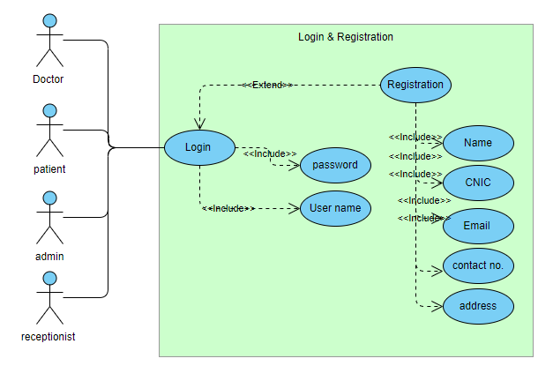

**Figure 3.1.1-UC-01-Login and Registration**

* + 1. **Use Case “Manage Profile”**

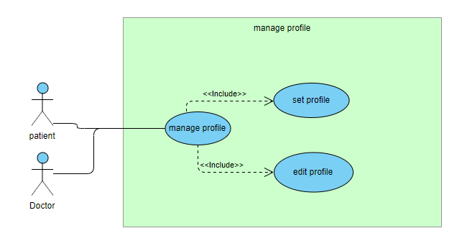**Figure 3.1.2-UC-02-Manage Profile**

* + 1. **Use Case “Logout”**

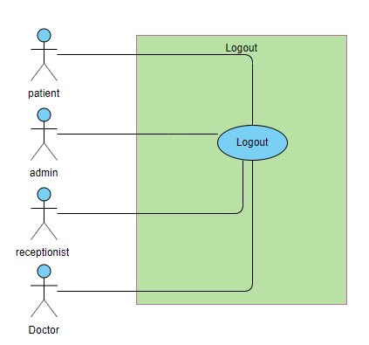

**Figure 3.1.3-UC-03-Logout**

* + 1. **Use Case “Search”**

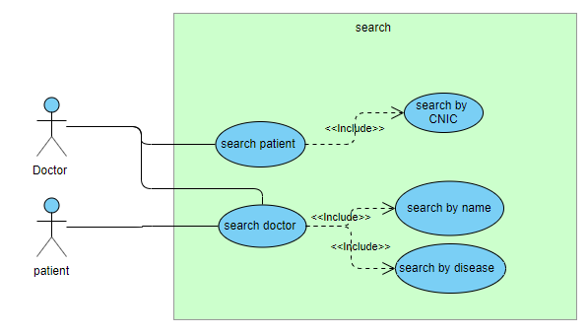

**Figure 3.1.4-UC-04-search**

* + 1. 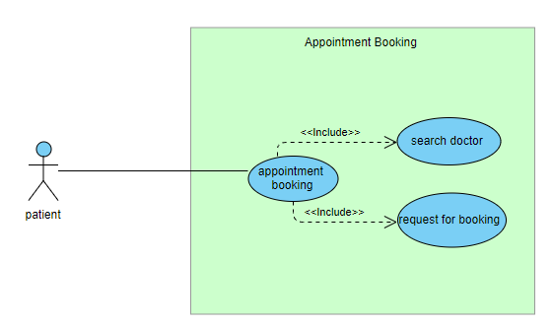 **Use Case “Appointment Booking”**

**Figure 3.1.5-UC-05-Appointment Booking**

* + 1. **Use Case “Booking Response”**

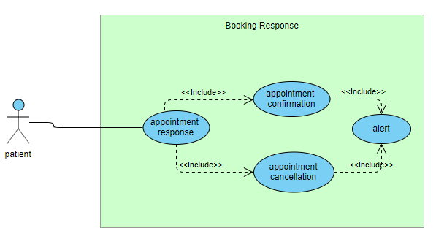

**Figure 3.1.6-UC-06-Booking Response**

* + 1. **Use Case “Rating a Doctor”**

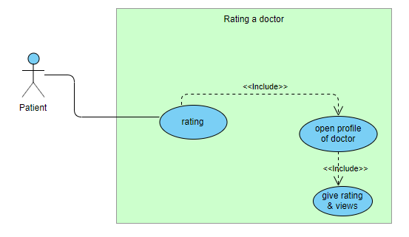

**Figure 3.1.7-UC-07-Rating a doctor**

* + 1. **Use Case “Medicine Reminder”**

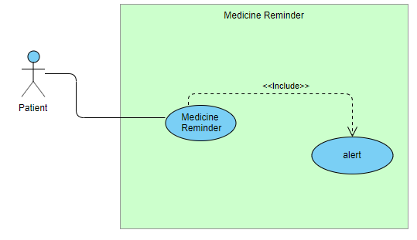

**Figure 3.1.8-UC-08-Medicine Reminder**

* + 1. **Use Case “Change Password”**

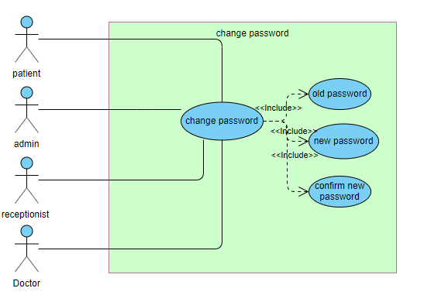

**Figure 3.1.9-UC-09-Change Password**

* + 1. **Use Case “Communication b/w Doc & Patient”**

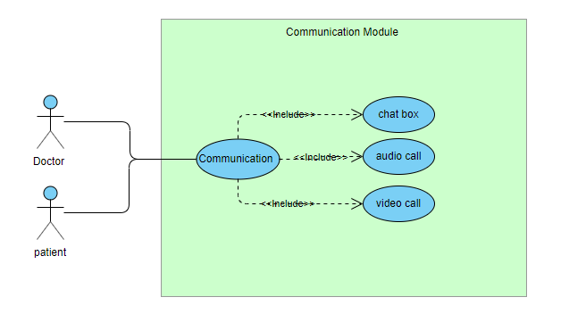

**Figure 3.1.10-UC-10-Communication between doctor & patient**

* + 1. **Use Case “Examine Prescription”**

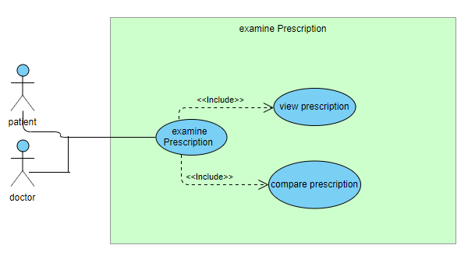

**Figure 3.1.11-UC-11-Examine Prescription**

* + 1. **Use Case “Online Medical Consultant”**

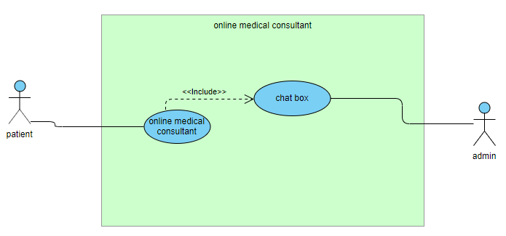

**Figure 3.1.12-UC-12-Online Medical Consultant**

* + 1. **Use Case “Online Prescription”**

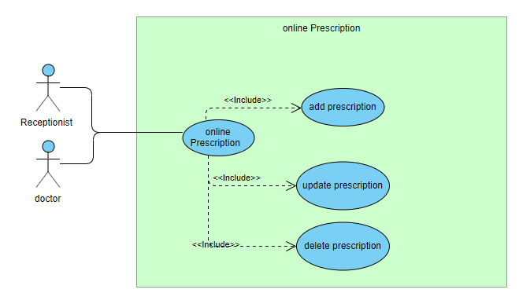

**Figure 3.1.13-UC-13-Online Prescription**

* + 1. 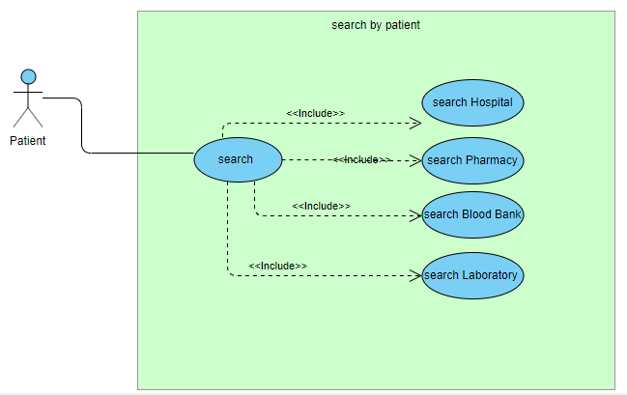**Use Case “Search by Patient”**

**Figure 3.1.14-UC-14-Search by Patient**

**3.1.15 Use Case “Manage Appointments”**

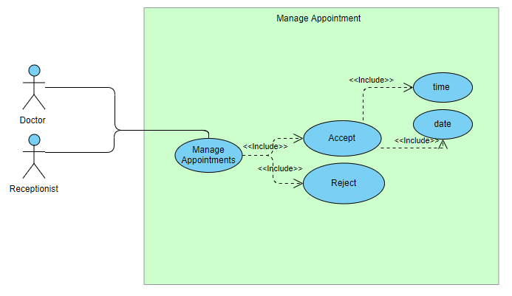

## Figure 3.1.15-UC-15-Manage appointments

**3.1.16 Use Case “Manage Medical Reports”**

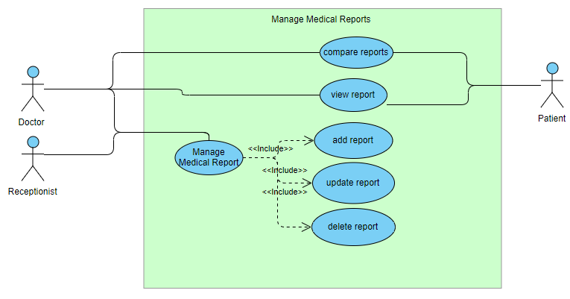

## Figure 3.1.16-UC-16-Manage Medical Reports

## 3.1.17 Use Case “Manage Hospital Details”

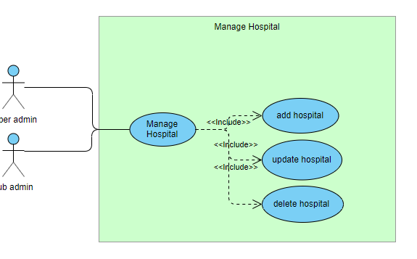

**Figure 3.1.17-UC-17-Manage Hospitals Details**

**3.1.18 Use Case “Manage Pharmacy”**

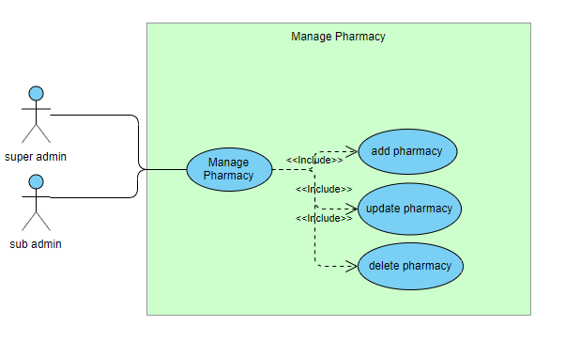

**Figure 3.1.18-UC-18-Manage Pharmacy Details**

## 3.1.19 Use Case “Manage Blood Bank”

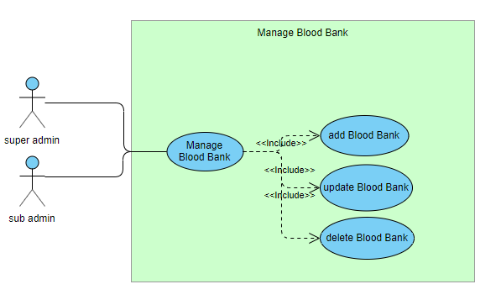

**Figure 3.1.19-UC-19-Manage Blood bank details**

**3.1.20 Use Case “Manage Laboratory Details”**

## 

**Figure 3.1.20-UC-20-Manage laboratory details**

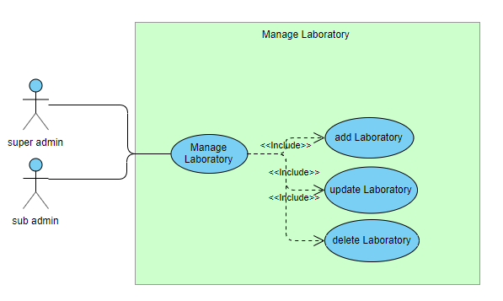

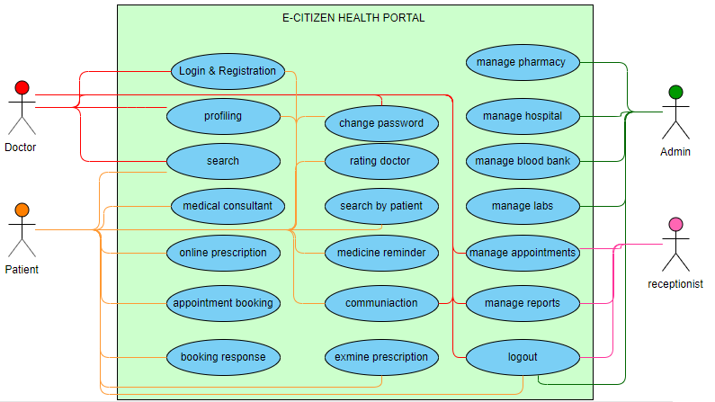**3.1.21 E-CITIZEN Health Portal**

**Figure 3.2.21- E-CITIZEN Health Portal**

* 1. **Fully Dressed Use Case**
     1. **Registration and Login**

|  |  |  |
| --- | --- | --- |
| **Use Case ID** | UC-01 | |
| **Use Case Name** | Registration and Login | |
| **Description** | Registration and login for all users | |
| **Primary Actor** | Doctor, Patient, Admin, Receptionist | |
| **Secondary Actor** | System/Software | |
| **Pre-Conditions** | The member is on the "Main screen” | |
| **Post Conditions** | The user is logged in and is appropriately notified. | |
| **Basic Flow** | Actor action | System Action |
|  | Press login  Login enter and press submit  Press signup if user don’t have account  Fill the form and press submit  Successfully registered | Open login form  Validate user name and password and allow to enter the system  Registration form will be displayed  System validates all fields and give notify  Store/save the data in data base |
| **Alternate Flow** | Invalid Information Entered: System displays message to enter correct information. | |

**Table 3.2.1-UC-01-Registration and Login**

**3.2.2 Logout**

|  |  |  |
| --- | --- | --- |
| **Use Case ID** | UC-02 | |
| **Use Case Name** | Log out | |
| **Description** | This module will allow the doctor to logout the system. | |
| **Primary Actor** | Doctor, Patient, Receptionist, Admin | |
| **Secondary Actor** | System/Software | |
| **Pre-Conditions** | The member is on the "Main/Home" screen. | |
| **Post Conditions** | Session will expired successfully | |
| **Basic Flow** | Actor Action | System Response |
|  | On home page press on log out  Successfully logged out from system  Use case ends. | On clicking the logout the session will expire  System will display home screen |
| **Alternate Flow** | Session does not expire due to slow internet speed | |

**Table 3.2.2-UC-02-Logout**

**3.2.3 Manage Profile**

|  |  |  |
| --- | --- | --- |
| **Use Case ID** | UC-03 | |
| **Use Case Name** | Manage profile | |
| **Description** | Setting and updating user profile by doctor and patient | |
| **Primary Actor** | Doctor, Patient | |
| **Secondary Actor** | System/Software | |
| **Pre-Conditions** | The member is on the "Main/Home" screen. | |
| **Post Conditions** | The profile is set up | |
| **Basic Flow** | Actor Action | System Response |
|  | Click on profile icon  Add new profile give all details and press save  Press on update  Update all things that the user want to update and press save | Display the profile page  System validates all the fields and save the profile  The data will updated and save in the data base |
| **Alternate Flow** | Invalid Information Entered: System displays message to enter correct information or data does not exist in the data base. | |

**Table 3.2.3-UC-03-Manage Profile**

**3.2.4 Search**

|  |  |  |
| --- | --- | --- |
| **Use Case ID** | UC-04 | |
| **Use Case Name** | Search | |
| **Description** | Searching the patient and the doctor | |
| **Primary Actor** | Doctor, Patient | |
| **Secondary Actor** | System/Software | |
| **Pre-Conditions** | The member is on the "Main/Home" screen. | |
| **Post Conditions** | Searched data will be displayed on screen | |
| **Basic Flow** | Actor Action | System Response |
|  | Click on search  Enter the name of doctor or disease to search the doctor  Doctor can search the patient by his CNIC number give CNIC number and search | All the relevant result will be displayed of doctors user will select the doctor  Only one patient will be displayed because each patient have a unique CNIC number |
| **Alternate Flow** | Invalid Information Entered: System displays message to enter correct information or data does not exist in the data base. | |

**Table 3.2.4-UC-04-Search**

**3.2.5 Appointment Booking**

|  |  |  |
| --- | --- | --- |
| **Use Case ID** | UC-05 | |
| **Use Case Name** | appointment booking | |
| **Description** | This module helps to patient to book an appointment | |
| **Primary Actor** | Patient | |
| **Secondary Actor** | System/Software | |
| **Pre-Conditions** | Internet connectivity. | |
| **Post Conditions** | Appointment request will be send to doctor’s account | |
| **Basic Flow** | Actor Action | System Response |
|  | Search a doctor  Open profile of doctor  Click on appointment booking request  Request will be send 2 days before appointment  Use case ends. | Doctors will displayed  Doctors profile will be displayed  Request will send to doctor for appointment  Saved the data in database |
| **Alternate Flow** | Sending more than one appointment booking request from one account | |

**Table 3.2.5-UC-05-Appointment Booking**

**3.2.6 Booking Response**

|  |  |  |
| --- | --- | --- |
| **Use Case ID** | UC-06 | |
| **Use Case Name** | Booking Response | |
| **Description** | This module helps to patient to book an appointment | |
| **Primary Actor** | Patient | |
| **Secondary Actor** | System/Software | |
| **Pre-Conditions** | Internet connectivity. | |
| **Post Conditions** | Appointment request will be send to doctor’s account | |
| **Basic Flow** | Actor Action | System Response |
|  | Alert will displayed  Click on alert to make reminder in mobile  Enable or disable the alert | System will display a alert of booking confirmation  System will display a alert of booking confirmation  Data will saved in data base |
| **Alternate Flow** | No alert is displayed on screen | |

**Table 3.2.6-UC-06-Booking Response**

**3.2.7 Rating a Doctor**

|  |  |  |
| --- | --- | --- |
| **Use Case ID** | UC-07 | |
| **Use Case Name** | Rating a Doctor | |
| **Description** | Help the patient to rate and review a doctor | |
| **Primary Actor** | Patient | |
| **Secondary Actor** | System/Software | |
| **Pre-Conditions** | Internet connectivity. | |
| **Post Conditions** | Rating will displayed on the doctors profile | |
| **Basic Flow** | Actor Action | System Response |
|  | Search a doctor  Open profile of doctor  Add rating in stars  Give some reviews about doctor  Use case ends. | Doctors will displayed  Doctors profile will be displayed  Rating will be added at doctor’s profile  Reviews will filtered automatically is that are spam or fake  Save the data in data base |
| **Alternate Flow** | Giving the fake and spam reviews on doctor’s profile | |

**Table 3.2.7-UC-07-Rating a Doctor**

**3.2.8 Medicine Reminder**

|  |  |  |
| --- | --- | --- |
| **Use Case ID** | UC-08 | |
| **Use Case Name** | Medicine reminder | |
| **Description** | This module helps to patient to get reminder of medicine | |
| **Primary Actor** | Patient | |
| **Secondary Actor** | System/Software | |
| **Pre-Conditions** | Internet connectivity. | |
| **Post Conditions** | Medicine alert will be shown on screen | |
| **Basic Flow** | Actor Action | System Response |
|  | Alert will be shown on screen of medicine  Alert can be disable by the settings  Use case ends. | Display the alert on screen  Disabled and enable the alerts by the user options |
| **Alternate Flow** | Might be patient ignore the alert | |

**Table 3.2.8-UC-08-Medicine Reminder**

**3.2.9 Change Password**

|  |  |  |
| --- | --- | --- |
| **Use Case ID** | CS-09 | |
| **Use Case Name** | Change password | |
| **Description** | Help the users to change the password | |
| **Primary Actor** | Doctor, Patient, Admin, Receptionist | |
| **Secondary Actor** | System/Software | |
| **Pre-Conditions** | The member is on the "Main/Home" screen. | |
| **Post Conditions** | Password will be changed | |
| **Basic Flow** | Actor Action | System Response |
|  | Go to personal history page  Press account setting  Press the change password button  Give current password  Give new password  Re write the new password  Save the record in data base  Use case ends. | Personal history page will be opened  Change password page will be displayed  Validate the current password  Matching new password and confirm new password  Password changed and save in data base |
| **Alternate Flow** | Password does not contain 8 letter with alphabetic number  Saving the current password as a new password | |

**Table 3.2.9-UC-09-Change Password**

**3.2.10 Communication b/w Doctor and Patient**

|  |  |  |
| --- | --- | --- |
| **Use Case ID** | UC-10 | |
| **Use Case Name** | Communication between doctor & patient | |
| **Description** | Help the users to communicate with each other | |
| **Primary Actor** | Doctor, Patient | |
| **Secondary Actor** | System/Software | |
| **Pre-Conditions** | The member is on the "Main/Home" screen. | |
| **Post Conditions** | Communication will be done and save history in db. | |
| **Basic Flow** | Actor Action | System Response |
|  | Search a doctor/patient  Select the communication option like chat or audio/video call  Communication done between users | Display the doctor  Make audio/video call or open the chat box according to the user choice  Save the history of chat and calls in data base |
| **Alternate Flow** | Chat and call at the same time  Pressing chat button during call | |

**Table 3.2.10-UC-10-Communication between doctor & patient**

**3.2.11 Examine Prescription**

|  |  |  |
| --- | --- | --- |
| **Use Case ID** | UC-11 | |
| **Use Case Name** | Examine the prescriptions | |
| **Description** | Comparison between 2 prescription will be done | |
| **Primary Actor** | Doctor, Patient | |
| **Secondary Actor** | System/Software | |
| **Pre-Conditions** | The member is on the "Main/Home" screen. | |
| **Post Conditions** | Comparison will be done and can be download | |
| **Basic Flow** | Actor Action | System Response |
|  | Open the prescription pages  Select 1 prescription to view  Select 2 prescription to compare  Download it | Display prescription page  Prescription will be displayed  Comparison page will be displayed  Files will be download to the memory |
| **Alternate Flow** | Adding more than two files during comparison  The patient have only one prescription which cannot be compare | |

**Table 3.2.11-UC-11-Examine Prescription**

**3.2.12 Online Medical Consultant**

|  |  |  |
| --- | --- | --- |
| **Use Case ID** | UC-12 | |
| **Use Case Name** | online medical consultant | |
| **Description** | This module helps to patient to get any kind of help regarding to health | |
| **Primary Actor** | Patient | |
| **Secondary Actor** | System/Software | |
| **Pre-Conditions** | Internet connectivity. | |
| **Post Conditions** | Message will be sent to online health care consultant | |
| **Basic Flow** | Actor Action | System Response |
|  | Patient will be on home screen  Clicking on the ‘help box’  A message box will be opened  Write and send message to online medical consultant  Consultant will reply within 24hours  Use case ends. | Chat box will be opened  Auto respondent will be send to patient  Message by patient will be send to admin  They will response it as soon as possible |
| **Alternate Flow** | Sending fake and spam messages | |

**Table 3.2.12-UC-12-Online Medical Consultant**

**3.2.13 Online Prescription**

|  |  |  |
| --- | --- | --- |
| **Use Case ID** | UC-13 | |
| **Use Case Name** | online prescription | |
| **Description** | This module helps to doctors and receptionist to add new, update and delete prescriptions | |
| **Primary Actor** | Doctor, Receptionist | |
| **Secondary Actor** | System/Software | |
| **Pre-Conditions** | Internet connectivity. | |
| **Post Conditions** | Prescription will added new or updated or deleted | |
| **Basic Flow** | Actor Action | System Response |
|  | Add new  Search the patient and add the prescription and save it to db.  Update  Search the patient and click on update  Update all data or selected data and press update  Delete  Search the patient  Select the prescription which is to be delete and delete it | Display the patient and store the new prescription in the data base  Display the patient and give access to updated the selected prescription and save it in db.  Display the patient and allow to delete the prescription from data base. |
| **Alternate Flow** | Deleting all the data from data base. | |

**Table 3.2.13-UC-13-Online Prescription**

**3.2.14 Search by Patient**

|  |  |  |
| --- | --- | --- |
| **Use Case ID** | UC-14 | |
| **Use Case Name** | Search by the patient | |
| **Description** | Helps patient to search the hospitals, pharmacy, blood banks and Labs | |
| **Primary Actor** | Patient | |
| **Secondary Actor** | System/Software | |
| **Pre-Conditions** | Internet connectivity. | |
| **Post Conditions** | Desired result will be displayed | |
| **Basic Flow** | Actor Action | System Response |
|  | Click on search  Give name and search  Add filter on the result like only hospital, pharmacy , labs or blood bank  View the data  Use case ends | Display all the hospitals, pharmacies, blood banks, and labs  Display only Filtered data on users choice |
| **Alternate Flow** | Deleting all the data from data base. | |

**Table 3.2.14-UC-14-Search by Patient**

**3.2.15 Manage Appointments**

|  |  |  |
| --- | --- | --- |
| **Use Case ID** | UC-15 | |
| **Use Case Name** | Manage Appointments | |
| **Description** | This module will allow the doctor to approve and reject the patients request for appointment | |
| **Primary Actor** | Doctor, Receptionist | |
| **Secondary Actor** | System/Software | |
| **Pre-Conditions** | The member is on the "Main/Home" screen. | |
| **Post Conditions** | Approve or reject the appointment | |
|  | Actor Action | System Response |
| **Basic Flow** | Press the button to view the all appointments request  Press accept or reject for each appointment  In the case of acceptance give the time and date  And press save  Use case ends. | Display all requests for appointments  Accepting and rejecting the appointments and then hide it from screen  Saving the date and time in data base and sending alerts to the patients |
| **Alternate Flow** | By mistake doctor reject the appointment request | |

**Table 3.2.15-UC-15-Manage appointments**

**3.2.16 Manage Medical Reports**

|  |  |  |
| --- | --- | --- |
| **Use Case ID** | UC-16 | |
| **Use Case Name** | Manage Medical Reports | |
| **Description** | This module helps to doctors and receptionist to add new, update and delete Reports and patient can view and compare it. | |
| **Primary Actor** | Doctor, Receptionist, Patient | |
| **Secondary Actor** | System/Software | |
| **Pre-Conditions** | Internet connectivity. | |
| **Post Conditions** | Medical Reports will added new or updated or deleted | |
| **Basic Flow** | Actor Action | System Response |
|  | Add new  Search the patient and add the Report and save it to db.  Update  Search the patient and click on update  Update all data or selected data and press update  Delete  Search the patient ,Select the medical reports which is to be delete and delete it  Patient and doctors can view and compare reports by selecting compare | Display the patient and store the new reports in the data base  Display the patient and give access to updated the selected reports and save it in db.  Display the patient and allow to delete the reports from data base.  Comparison will be displayed on screen |
| **Alternate Flow** | Deleting all the data from data base. | |

**Table 3.2.16-UC-16-Manage Medical Reports**

**3.2.17 Manage Hospital Details**

|  |  |  |
| --- | --- | --- |
| **Use Case ID** | UC-17 | |
| **Use Case Name** | Manage Hospitals Details | |
| **Description** | This module helps to admins and sub admins to add new, update and delete the details of hospitals | |
| **Primary Actor** | Admin, Sub admin | |
| **Secondary Actor** | System/Software | |
| **Pre-Conditions** | Internet connectivity. | |
| **Post Conditions** | Hospital record will added new or updated or deleted | |
| **Basic Flow** | Actor Action | System Response |
|  | Add new  Add the details of hospital and save it  Update  Search the hospital and click on update, Update all data or selected data and press update  Delete  Search the Hospital ,and delete the data | Add new details of hospitals and save it  Display the hospital and give access to updated the selected data and save it in db.  Display the hospital and allow to delete the all data from data base. |
| **Alternate Flow** | Adding fake hospitals which does not exist | |

**Table 3.2.17-UC-17-Manage Hospitals Details**

**3.2.18 Manage Pharmacy Details**

|  |  |  |
| --- | --- | --- |
| **Use Case ID** | UC-18 | |
| **Use Case Name** | Manage pharmacy Details | |
| **Description** | This module helps to admins and sub admins to add new, update and delete the details of pharmacy | |
| **Primary Actor** | Admin, Sub admin | |
| **Secondary Actor** | System/Software | |
| **Pre-Conditions** | Internet connectivity. | |
| **Post Conditions** | Hospital record will added new or updated or deleted | |
| **Basic Flow** | Actor Action | System Response |
|  | Add new  Add the details of pharmacy and save it  Update  Search the pharmacy and click on update, Update all data or selected data and press update  Delete  Search the pharmacy ,and delete the data | Add new details of pharmacy and save it  Display the pharmacy and give access to updated the selected data and save it in db.  Display the pharmacy and allow to delete the all data from data base. |
| **Alternate Flow** | Adding fake pharmacy which does not exist | |

**Table 3.2.18-UC-18-Manage Pharmacy Details**

**3.2.19 Manage Blood Bank Details**

|  |  |  |
| --- | --- | --- |
| **Use Case ID** | UC-19 | |
| **Use Case Name** | Manage Blood bank Details | |
| **Description** | This module helps to admins and sub admins to add new, update and delete the details of Blood bank | |
| **Primary Actor** | Admin, Sub admin | |
| **Secondary Actor** | System/Software | |
| **Pre-Conditions** | Internet connectivity. | |
| **Post Conditions** | Hospital record will added new or updated or deleted | |
| **Basic Flow** | Actor Action | System Response |
|  | Add new  Add the details of Blood bank and save it  Update  Search the Blood bank and click on update, Update all data or selected data and press update  Delete  Search the Blood bank ,and delete the data | Add new details of Blood bank and save it  Display the Blood bank and give access to updated the selected data and save it in db.  Display the Blood bank and allow to delete the all data from data base. |
| **Alternate Flow** | Adding fake Blood bank which does not exist | |

**Table 3.2.19-UC-19-Manage Blood bank details**

**3.2.20 Manage Laboratory Details**

|  |  |  |
| --- | --- | --- |
| **Use Case ID** | UC-20 | |
| **Use Case Name** | Manage Laboratory Details | |
| **Description** | This module helps to admins and sub admins to add new, update and delete the details of laboratory | |
| **Primary Actor** | Admin, Sub admin | |
| **Secondary Actor** | System/Software | |
| **Pre-Conditions** | Internet connectivity. | |
| **Post Conditions** | Hospital record will added new or updated or deleted | |
| **Basic Flow** | Actor Action | System Response |
|  | Add new  Add the details of laboratory and save it  Update  Search the laboratory and click on update, Update all data or selected data and press update  Delete  Search the laboratory ,and delete the data | Add new details of laboratory and save it  Display the laboratory and give access to updated the selected data and save it in db.  Display the laboratory and allow to delete the all data from data base. |
| **Alternate Flow** | Adding fake laboratory which does not exist | |

**Table 3.2.20-UC-20-Manage laboratory details**

# Chapter 4

# System Design

**Chapter 4:** System Design

## Architecture Diagram

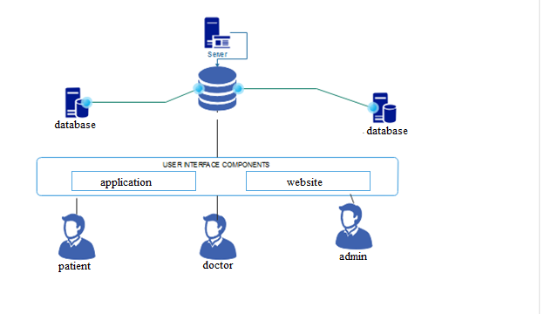

## Domain Model

[Paragraph Text 12 pt, Calibri, 1.5 Line Spacing, Justified]

## Entity Relationship Diagram

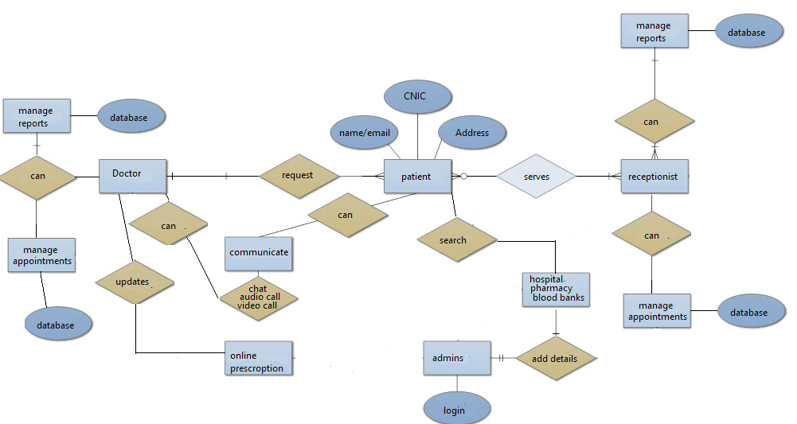

## Entity Relationship Diagram with data dictionary

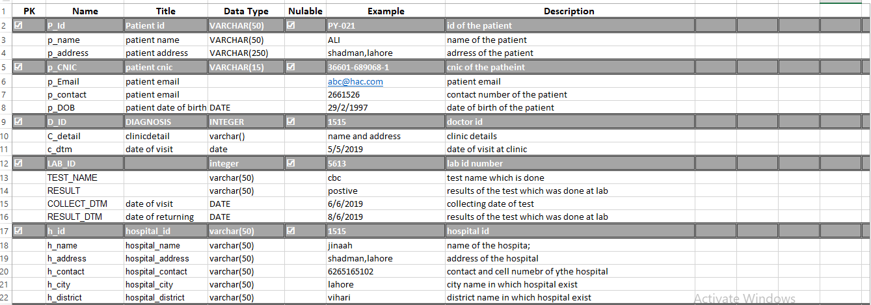

**Figure 4.4 ERD Data Dictionary (image 1)**

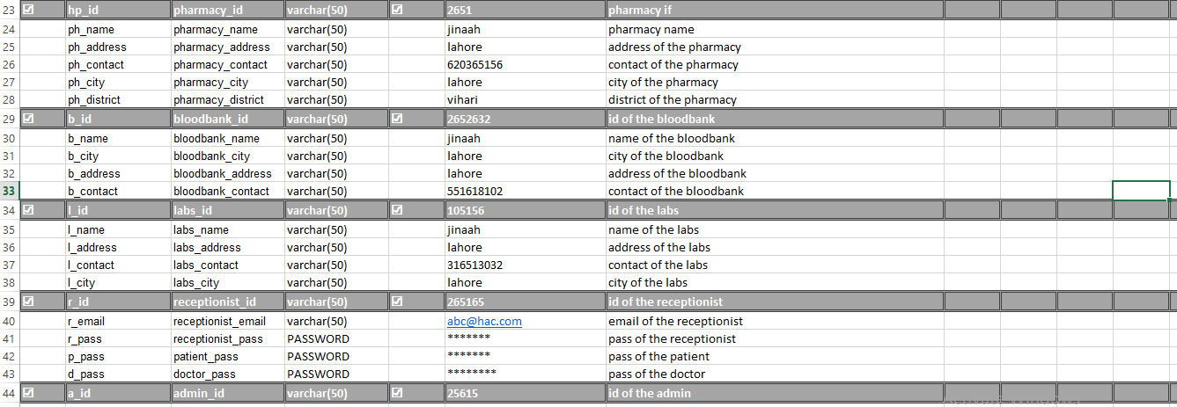

**Figure 4.41 ERD Data Dictionary (image 2)**

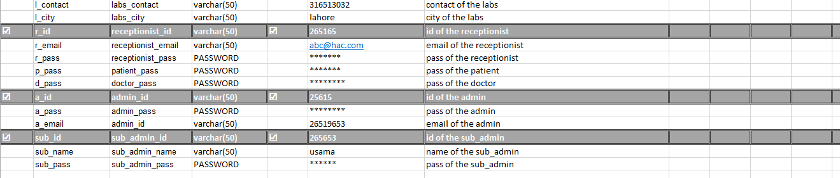

**Figure 4.42 ERD Data Dictionary (image 3)**

## Class Diagram

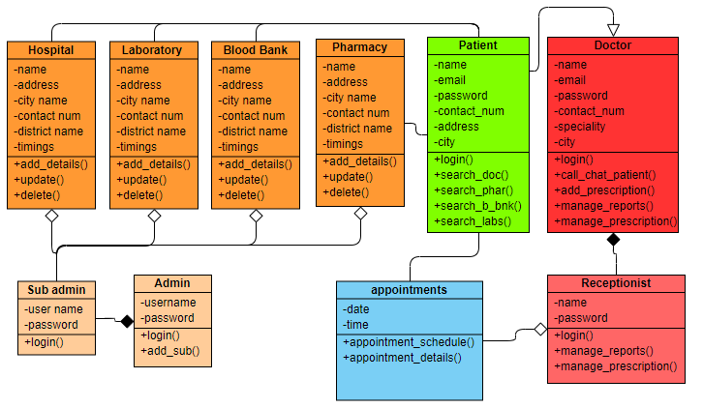

## Sequence Diagram

## Registration and Login

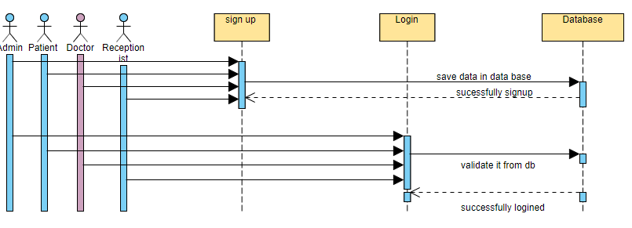

**Figure 4.6.1-SD-01-Login and Registration**

* + 1. **Logout**

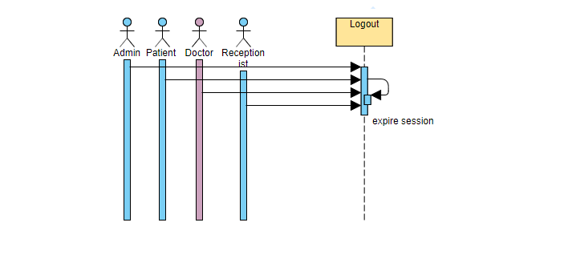

**Figure 4.6.2-SD-02-Logout**

* + 1. **Manage Profile**

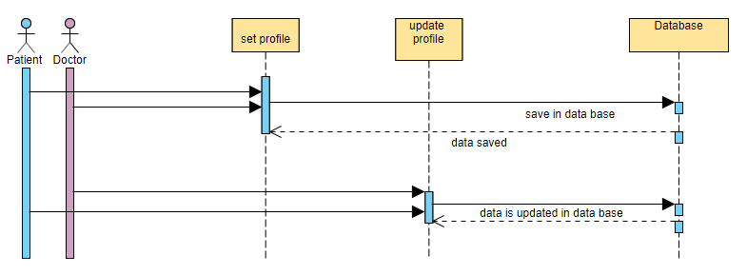

**Figure 4.6.3-SD-03-Manage Profile**

* + 1. **Search**

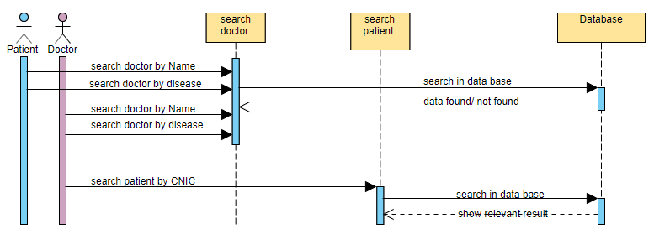

**Figure 4.6.4-SD-04-search**

* + 1. **Appointment Booking**

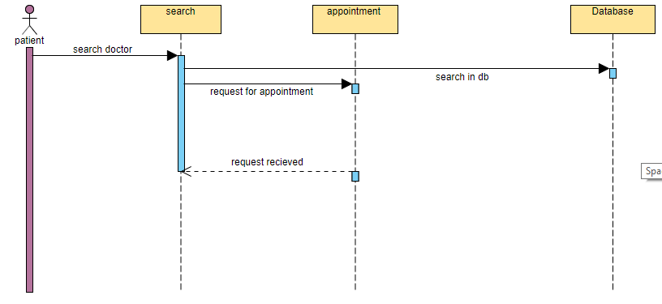

**Figure 4.6.5-SD-05-Appointment Booking**

* + 1. **Booking Response**

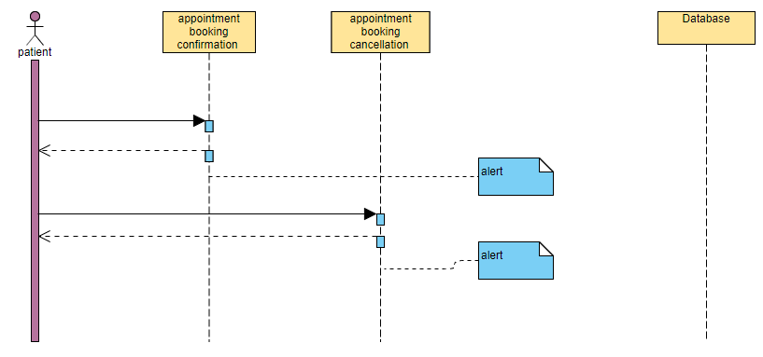

**Figure 4.6.6-SD-06-Booking Response**

* + 1. **Rating a Doctor**

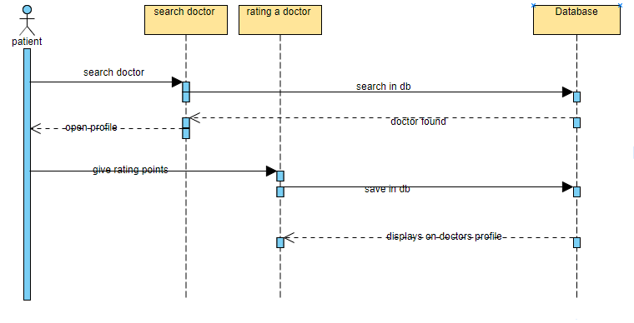

**Figure 4.6.7-SD-07-Rating a doctor**

* + 1. **Medicine Reminder**

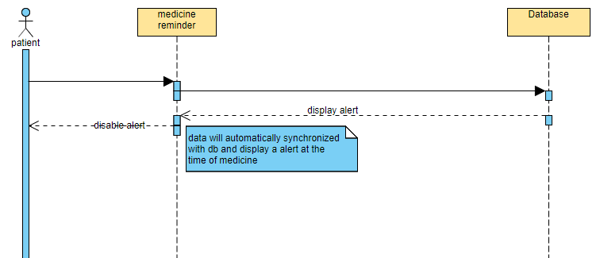

**Figure 4.6.8-SD-08-Medicine Reminder**

* + 1. **Change Password**

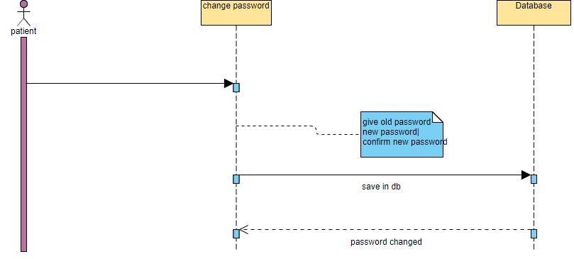

**Figure 4.6.9-SD-09-Change Password**

* + 1. **Communication between Doctor and Patient**

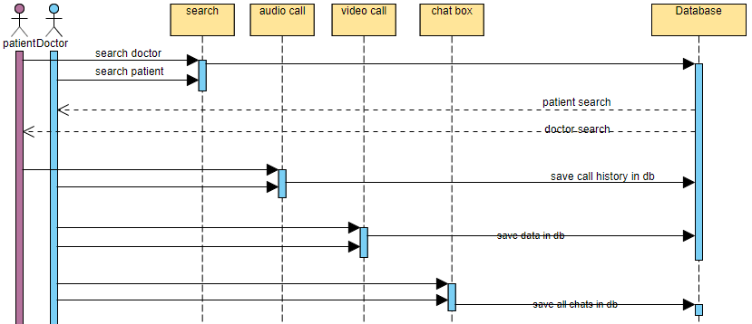

**Figure 4.6.10-SD-10-Communication between doctor & patient**

* + 1. **Examine Prescription**

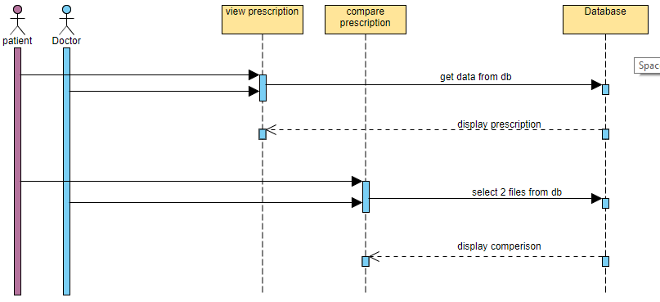

**Figure 4.6.11-SD-11-Examine Prescription**

* + 1. **Online Medical Consultant**

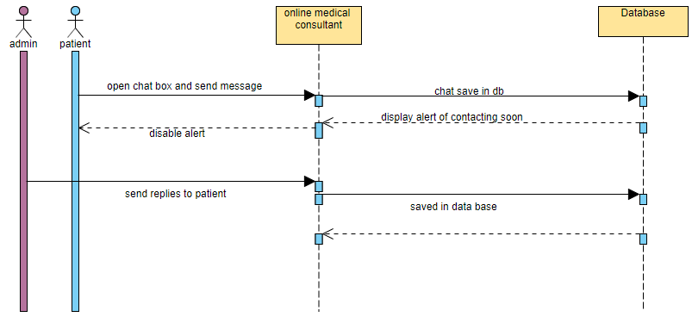

**Figure 4.6.12-SD-12-Online Medical Consultant**

* + 1. **Online Prescription**

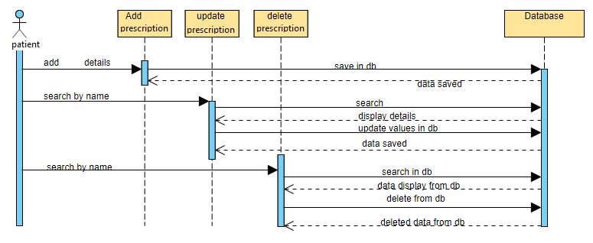

**Figure 4.6.13-SD-13-Online Prescription**

* + 1. **Search by Patient**

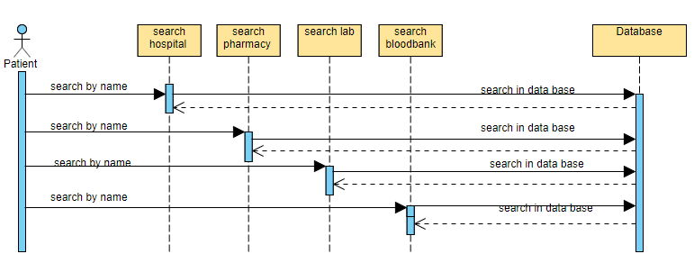

**Figure 4.6.14-SD-14-Search by Patient**

* + 1. **Manage Appointments**

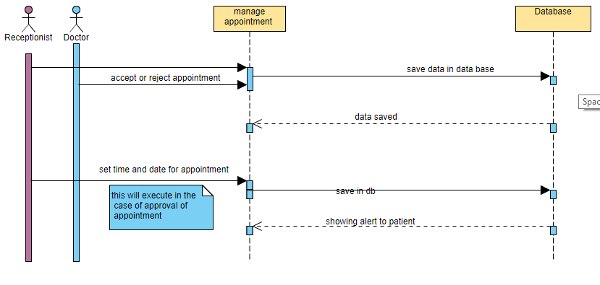

**Figure 4.6.15-SD-15-Manage appointments**

* + 1. **Manage Medical Reports**

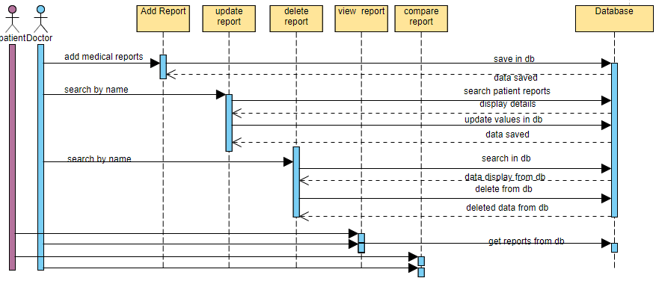

**Figure 4.6.16-SD-16-Manage Medical Reports**

* + 1. **Manage Hospital Details**

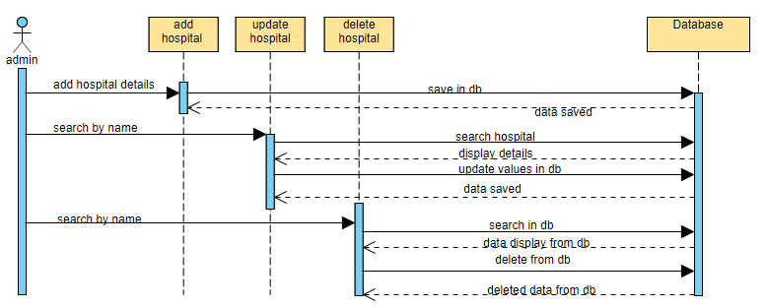

**Figure 4.6.17-SD-17-Manage Hospitals Details**

* + 1. **Manage Pharmacy Details**

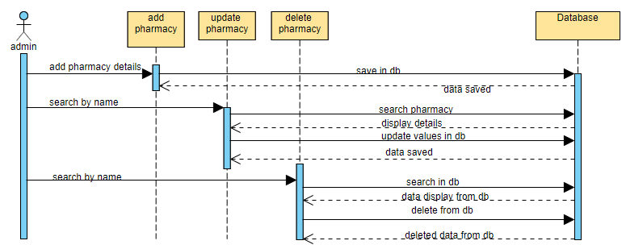

**Figure 4.6.18-SD-18-Manage Pharmacy Details**

* + 1. **Manage Blood Bank Details**

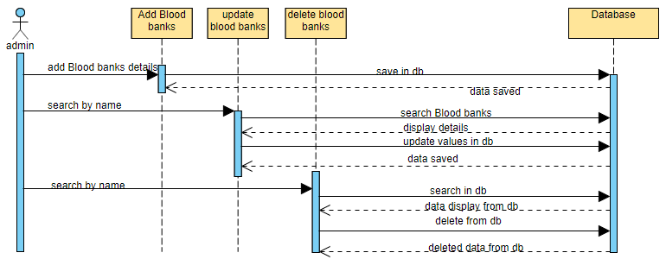

**Figure 4.6.19-SD-19-Manage Blood bank details**

* + 1. **Manage Laboratory Details**

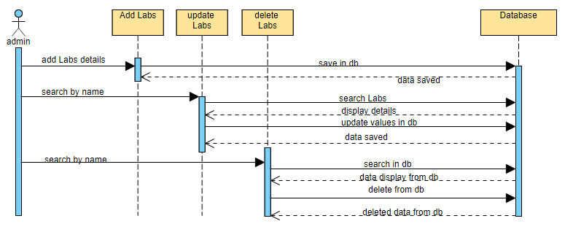

**Figure 4.6.20-SD-20-Manage laboratory details**

## Activity Diagram

* 1. **1 Registration and Login**

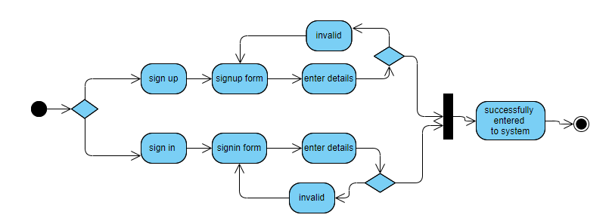

**Figure 4.7.1-AD-01-Login and Registration**

* + 1. **Logout**

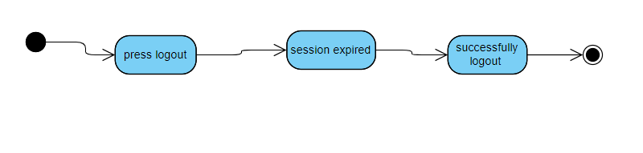

**Figure 4.7.2-AD-02-Logout**

**4.7.3 Manage Profile**

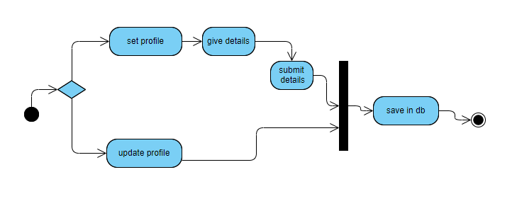

**Figure 4.7.3-AD-03-Manage Profile**

**4.7.4 Search**

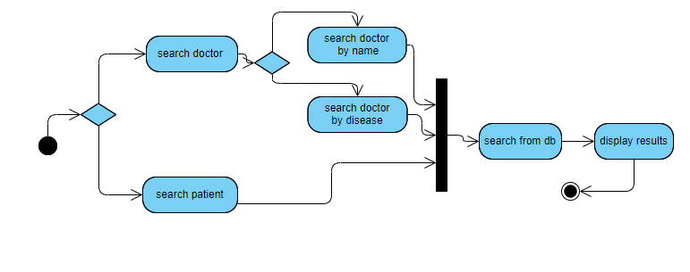

**Figure 4.7.4-AD-04-Search**

* + 1. **Appointment Booking**

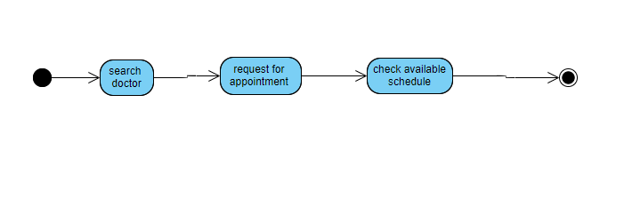

**Figure 4.7.5-AD-05-Appointment Booking**

* + 1. **Booking Response**

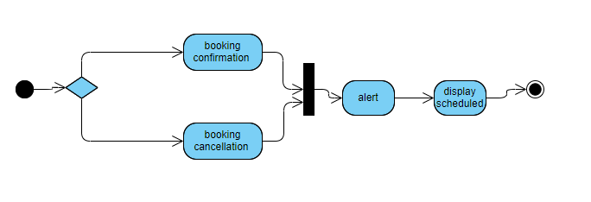

**Figure 4.7.6-AD-06-Booking Responce**

* + 1. **Rating a Doctor**

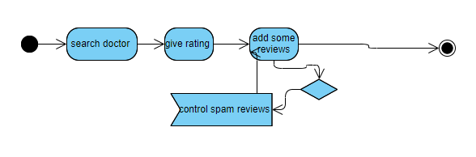

**Figure 4.7.7-AD-07-Rating a Doctor**

* + 1. **Medicine Reminder**

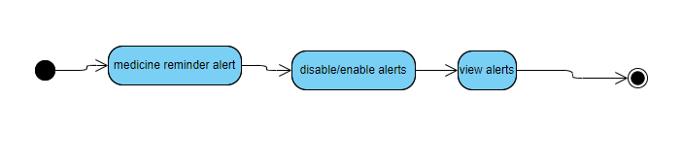

**Figure 4.7.8-AD-08-Medicine Reminder**

* + 1. **Change Password**

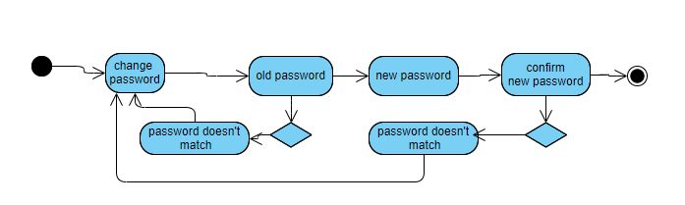

**Figure 4.7.9-AD-09-Change Password**

* + 1. **Communication between Doctor & Patient**

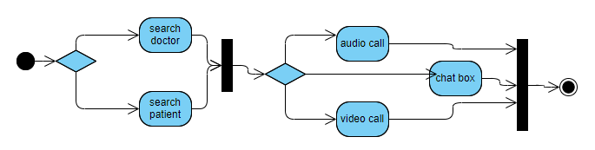

**Figure 4.7.10-AD-10-Communication b/w Doc & Patient**

* + 1. **Examine Prescription**

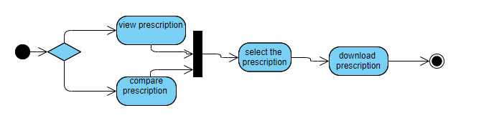

**Figure 4.7.11-AD-11-Examine Prescription**

* + 1. **Online Medical Consultant**

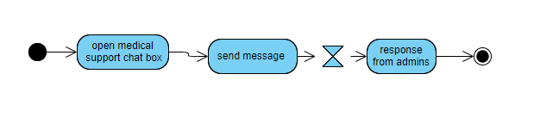

**Figure 4.7.12-AD-12-Online Medical consultant**

* + 1. **Online Prescription**

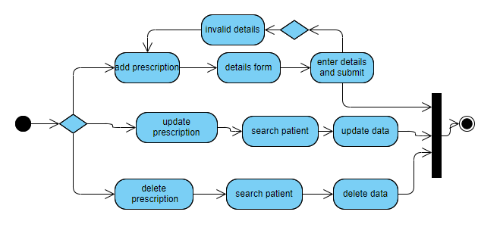

**Figure 4.7.13-AD-13-Online Prescription**

* + 1. **Search by Patient**

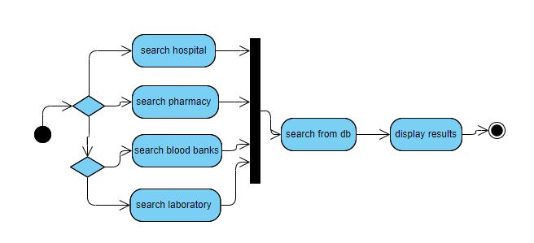

**Figure 4.7.14-AD-14-Search by Patient**

* + 1. **Manage Appointments**

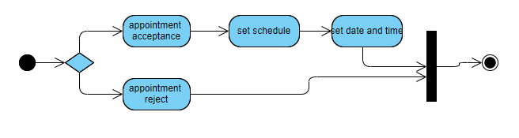

**Figure 4.7.15-AD-15-Manage Appointments**

* + 1. **Manage Medical Reports**

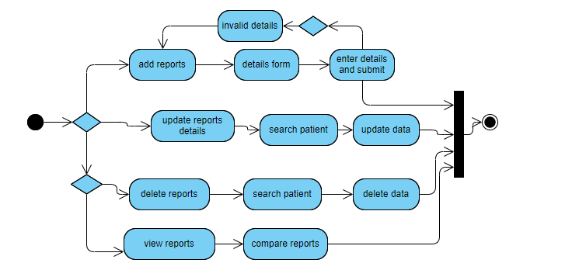

**Figure 4.7.16-AD-16-Manage Medical Reports**

* + 1. **Manage Hospital Details**

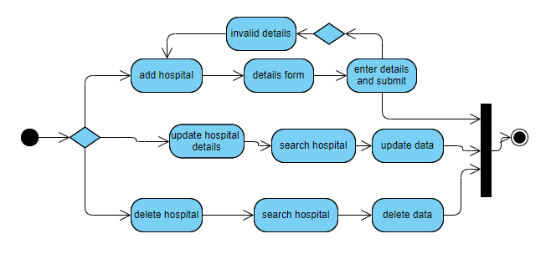

**Figure 4.7.17-AD-17-Manage Hospital Details**

* + 1. **Manage Pharmacy Details**

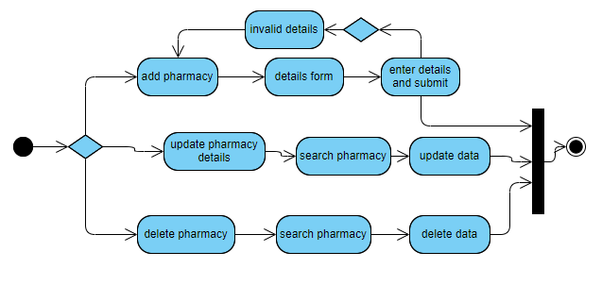

**Figure 4.7.18-AD-18-Manage Pharmacy Details**

* + 1. **Manage Blood Bank Details**

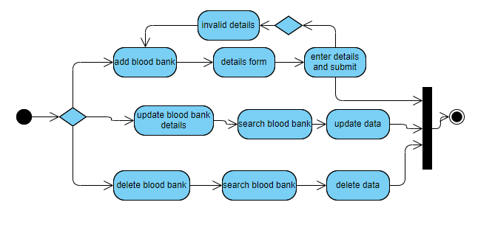

**Figure 4.7.19-AD-19-Manage Blood Bank Details**

* + 1. **Manage Laboratory Details**

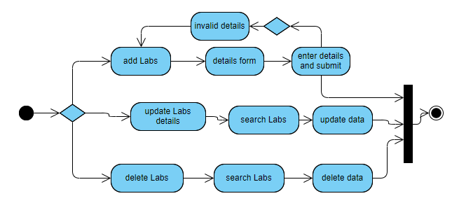

**Figure 4.7.20-AD-20-Manage Laboratory Details**

## State Transition Diagram

## Component Diagram

[Paragraph Text 12 pt, Calibri, 1.5 Line Spacing, Justified]

# Chapter 5

# Implementation

**Chapter 5:** Implementation

[Paragraph Text 12 pt, Calibri, 1.5 Line Spacing,Justified]

[*Between 4 to 8 lines describe what is this chapter all about*]

## Important Flow Control/Pseudo codes

[Paragraph Text 12 pt, Calibri, 1.5 Line Spacing, Justified]

## Components, Libraries, Web Services and stubs

[Paragraph Text 12 pt, Calibri, 1.5 Line Spacing, Justified]

## Deployment Environment

[Paragraph Text 12 pt, Calibri, 1.5 Line Spacing, Justified]

## Tools and Techniques

[Paragraph Text 12 pt, Calibri, 1.5 Line Spacing, Justified]

## Best Practices / Coding Standards

[Paragraph Text 12 pt, Calibri, 1.5 Line Spacing, Justified]

## Version Control

[Paragraph Text 12 pt, Calibri, 1.5 Line Spacing, Justified]

# Appendices

# Appendix A: Information / Promotional Material

[Paragraph Text 12 pt, Calibri, 1.5 Line Spacing,Justified]

[*Between 4 to 8 lines describe what is this appendix all about*]

* 1. **Broacher**

* 1. **Flyer**
  2. **Standee**
  3. **Banner**
  4. **First Level heading [16 pt, Calibri, Bold, Left aligned]**

[Paragraph Text 12 pt, Calibri, 1.5 Line Spacing, Justified]

* + 1. **Second level heading [14 pt, Calibri, Bold, Left aligned]**

[Paragraph Text 12 pt, Calibri, 1.5 Line Spacing, Justified]

* + - 1. **Third level heading [12 pt, Calibri, Bold, Left aligned]**

[Paragraph Text 12 pt, Calibri, 1.5 Line Spacing, Justified]

# Appendix [no.]: Appendix Title

[Paragraph Text 12 pt, Calibri, 1.5 Line Spacing,Justified]

[*Between 4 to 8 lines describe what is this chapter all about*]

* 1. **First Level heading [16 pt, Calibri, Bold, Left aligned]**

[Paragraph Text 12 pt, Calibri, 1.5 Line Spacing, Justified]

* + 1. **Second level heading [14 pt, Calibri, Bold, Left aligned]**

[Paragraph Text 12 pt, Calibri, 1.5 Line Spacing, Justified]

* + - 1. **Third level heading [12 pt, Calibri, Bold, Left aligned]**

[Paragraph Text 12 pt, Calibri, 1.5 Line Spacing, Justified]

# Reference and Bibliography

**Reference and Bibliography**

[1] M. Sher, M. Rehman, “*Title of the Paper*” Conference name/Journal Name, Edition, Volume, Issue, ISBN/ISSN, PP, Publisher/City-Country, Year.

[2] ……

# Index

**Index**

**[A]**

**[B]**

**[C]**